EC2 TASK

Task 1: Launch Amazon Linux 2 EC2 and Install Apache using User Data
Step 1: Launch EC2
- Login to AWS Console.
- Go to EC2 → Instances.
- Click Launch Instance.

Step 2: Configure Instance
Name
Apache-Server
AMI
Amazon Linux 2
Instance Type
t2.micro
Key Pair
Select your existing key pair
Network
Select your VPC
Select Public Subnet
Enable Auto-assign Public IP

Step 3: User Data
Expand Advanced Details.
Paste
#!/bin/bash
yum update -y
yum install httpd -y
systemctl start httpd
systemctl enable httpd
echo "<h1>Apache Installed Successfully</h1>" > /var/www/html/index.html

Step 4
Click
Launch Instance

Step 5 Verify
Copy the Public IPv4 address.
Open browser
http://Public-IP
Expected Output
Apache Installed Successfully
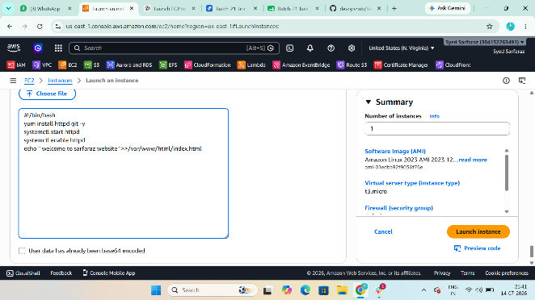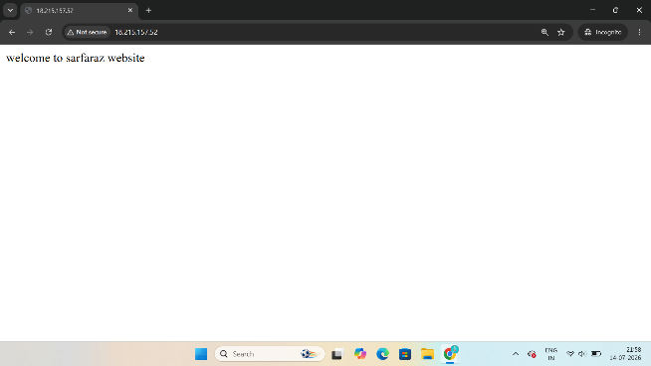

Task 2: Launch Ubuntu EC2 and Install Nginx using User Data
Step 1
Launch Instance

Step 2
Name
Nginx-Server
AMI
Ubuntu Server 24.04 LTS
Instance Type
t2.micro
Key Pair
Existing Key Pair
Network
Public Subnet
Auto Assign Public IP Enabled

Step 3 User Data
#!/bin/bash
apt update -y
apt install nginx -y
systemctl start nginx
systemctl enable nginx
echo "<h1>Nginx Installed Successfully</h1>" > /var/www/html/index.html

Step 4
Launch Instance

Step 5 Verify
Open
http://Public-IP
Output
Nginx Installed Successfully
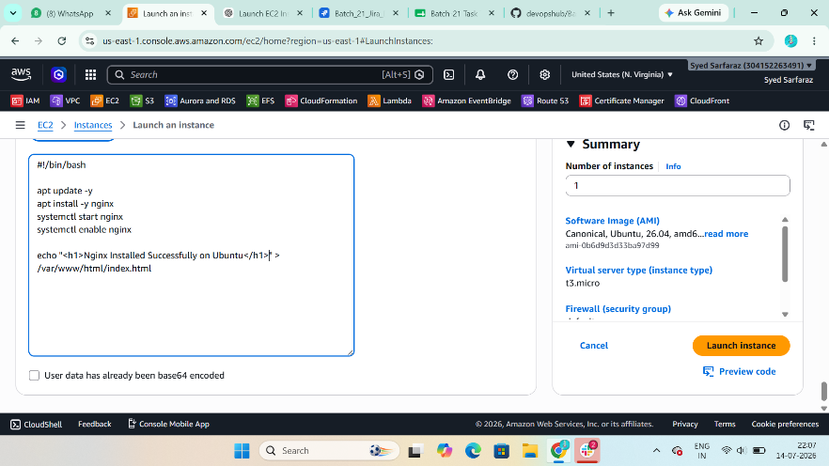
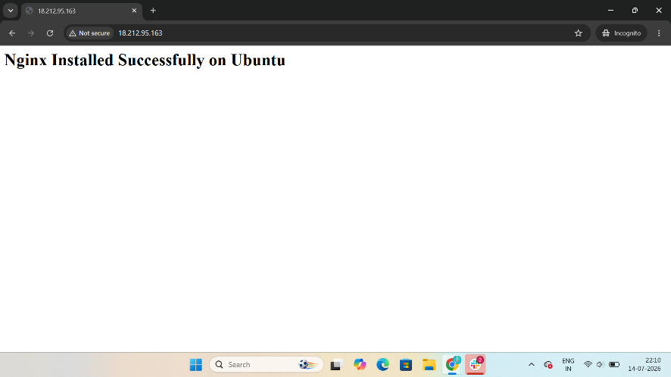

Task 3: Launch Windows Server and Install Tomcat
Step 1
Launch Instance
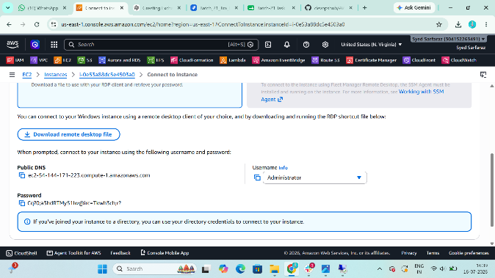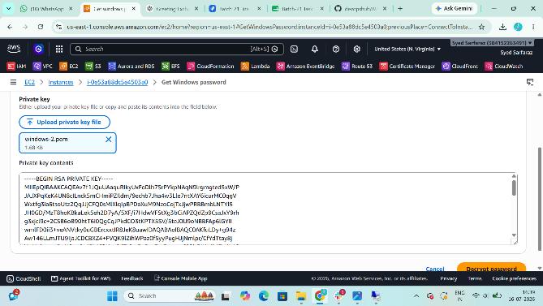

Step 2
Name
Windows-Tomcat
AMI
Microsoft Windows Server 2022 Base
Instance Type
t3.medium
Key Pair
Existing Key Pair
Launch Instance

Step 3
Wait until
Running

Step 4
Connect
Instance
→ Connect
→ RDP Client
Download RDP file.
Get Windows Password.
Login.
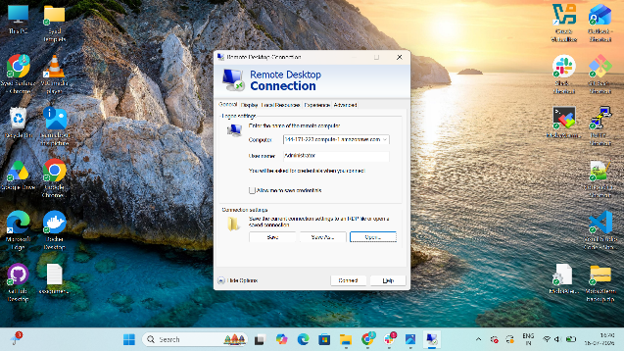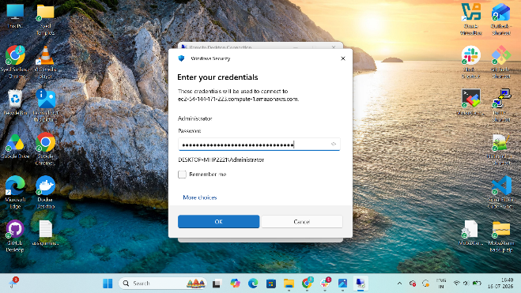

Step 5 Install Java
Open browser.
Download
JDK 21 (Windows x64)
Install with default settings.
Verify
Open CMD
java -version
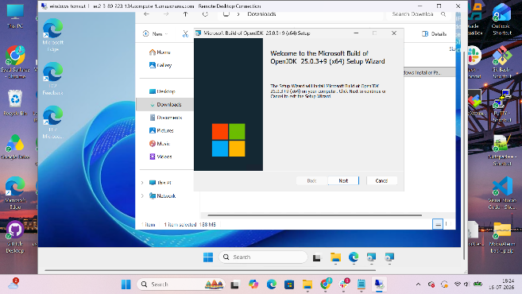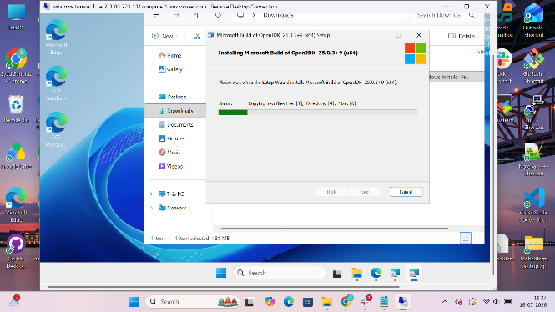
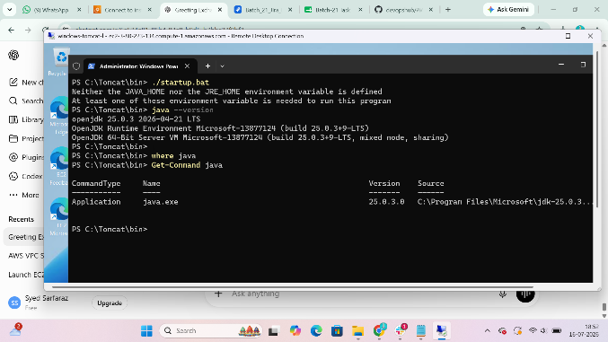

Step 6 Download Tomcat
Download
Apache Tomcat 10
Windows 64-bit ZIP
Extract to
C:\Tomcat
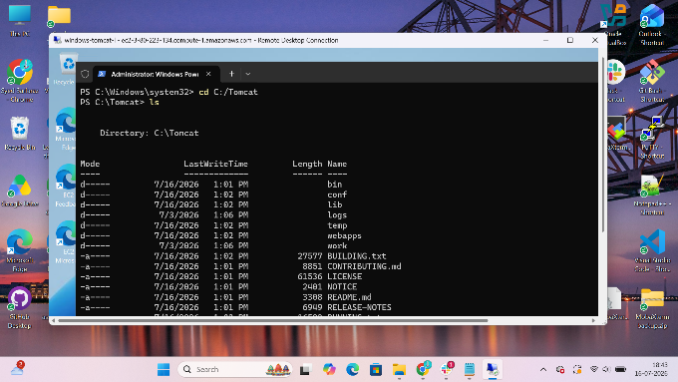

Step 7 Start Tomcat
Open
C:\Tomcat\bin
Double-click
startup.bat

Step 8 Verify
Browser
http://localhost:8080
or
http://Public-IP:8080
If accessing from the internet, add an inbound rule:
TCP 8080
Source: Anywhere
Expected
Apache Tomcat Welcome Page
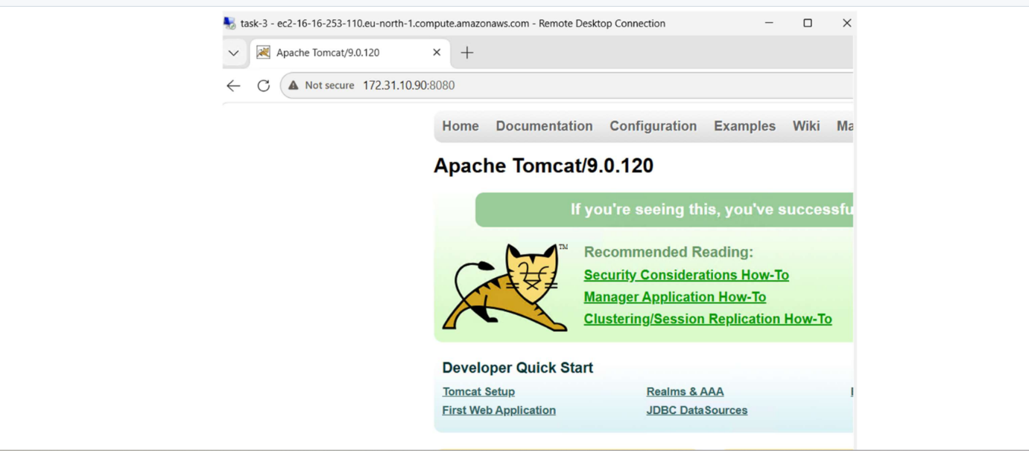

Task 4: Take Snapshot of Task 1 EC2
Go to
EC2
↓
Instances
↓
Select
Apache-Server
↓
Actions
↓
Image and Templates
↓
Create Image
or
Elastic Block Store
↓
Volumes
↓
Select Volume
↓
Actions
↓
Create Snapshot
Name
Apache-Snapshot
Click
Create Snapshot
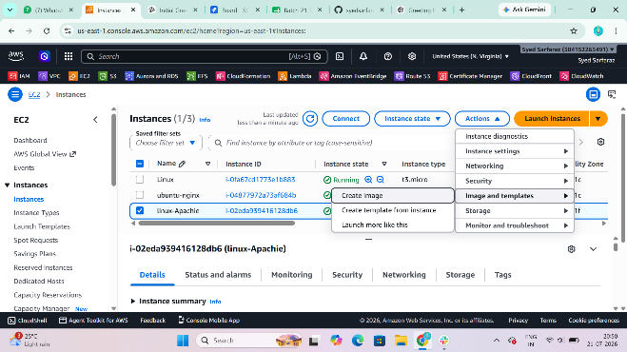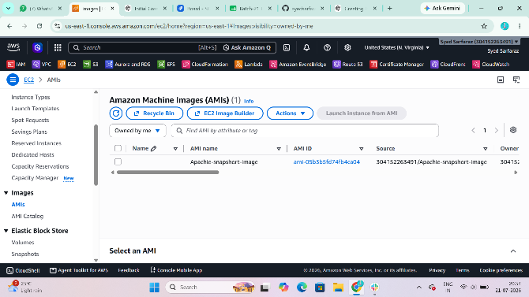

Task 5: Passwordless Authentication for Ubuntu EC2
Open terminal.
Generate key
ssh-keygen
Press Enter.
Copy public key
ssh-copy-id ubuntu@<Public-IP>
Connect
ssh ubuntu@<Public-IP>
You should log in without entering a password (using your SSH key).
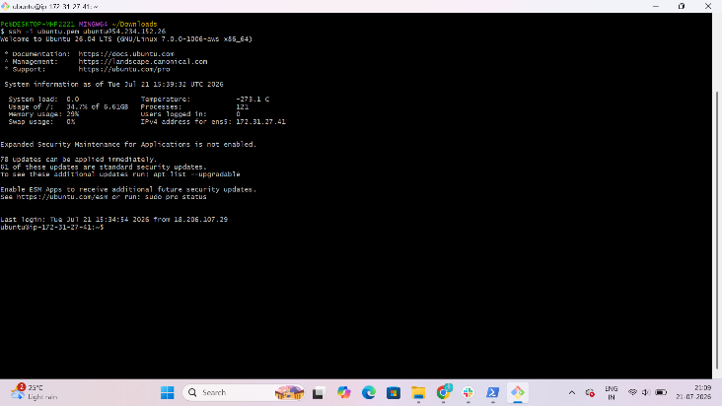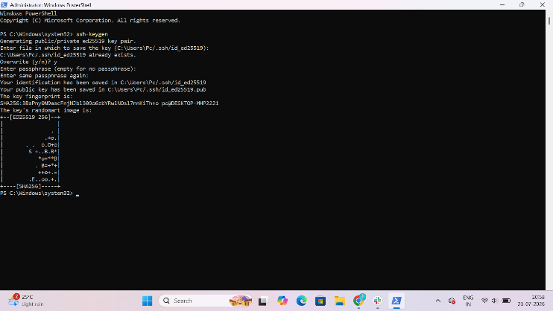
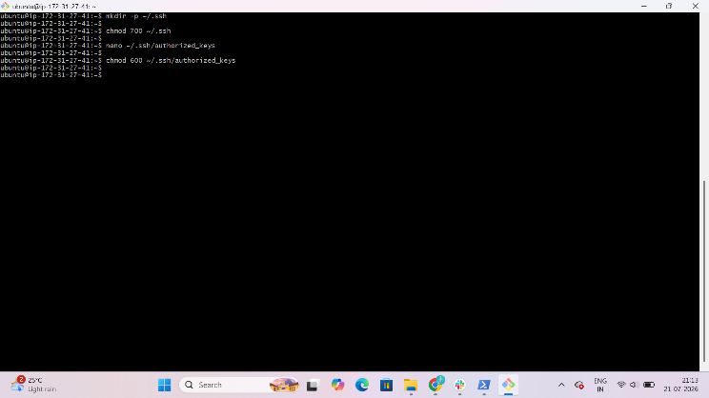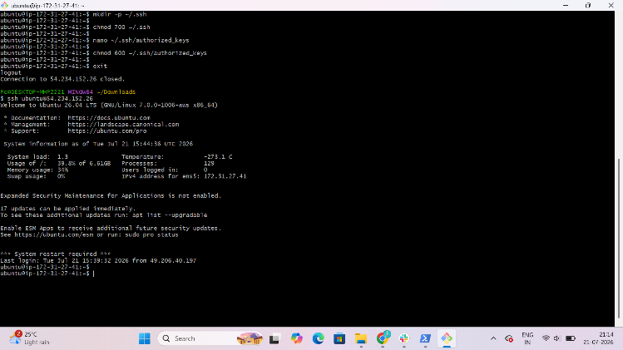

Task 6: Launch Spot Instance
Launch Instance.
Under
Advanced Details
Find
Request Spot Instance
Select
Request Spot Instance
Maximum Price
Leave Default
Launch Instance.
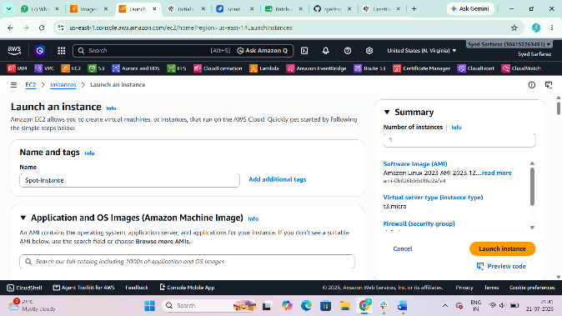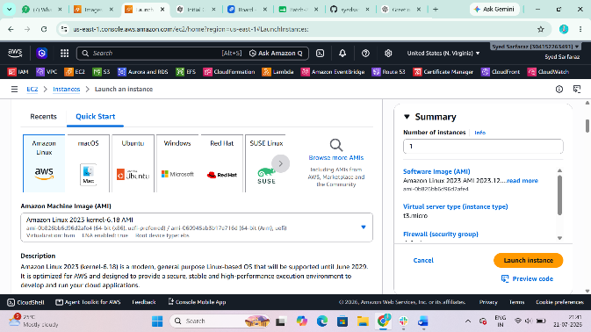

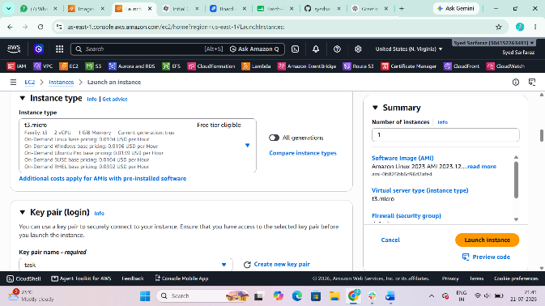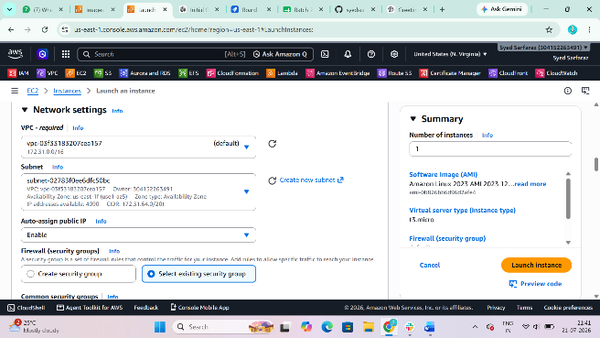

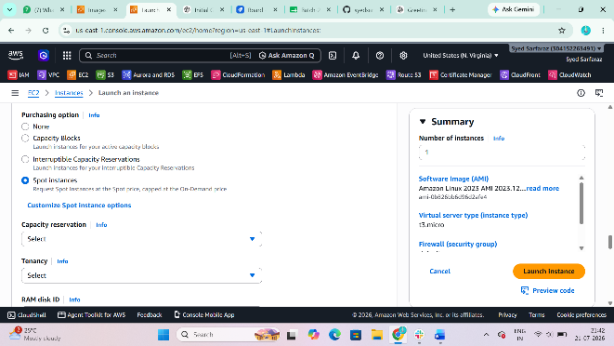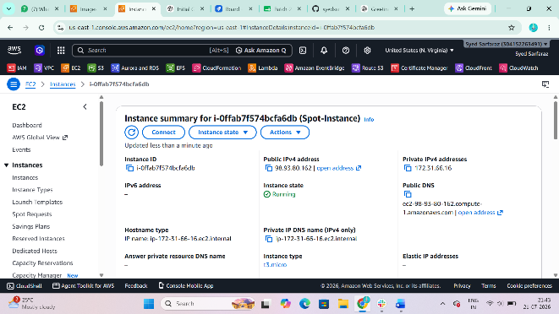

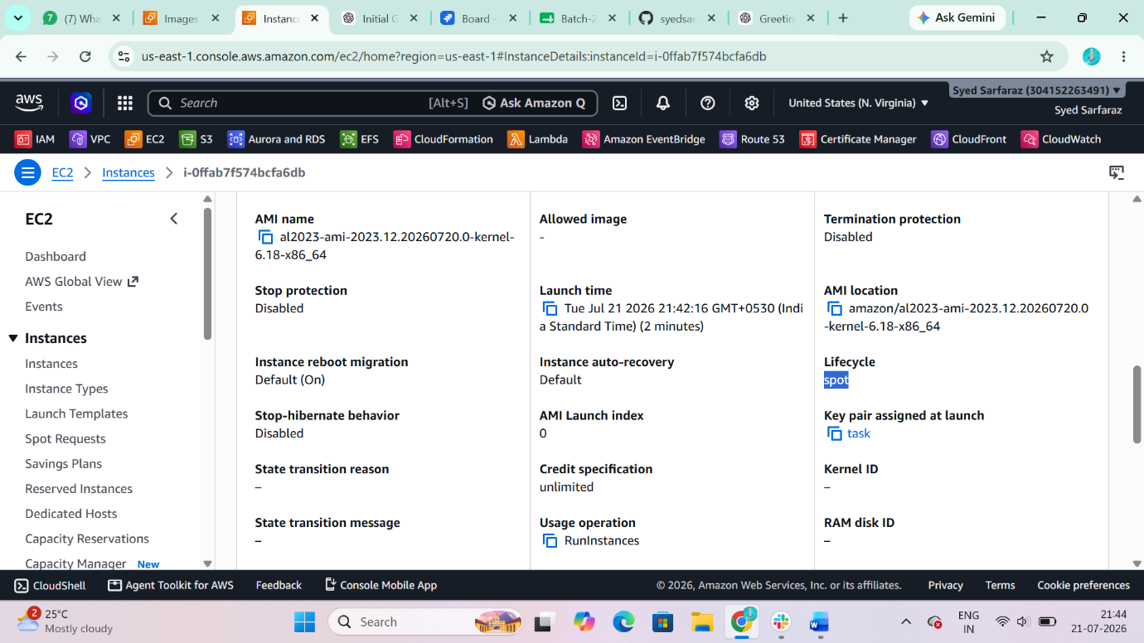

Task 7: Enable Termination Protection (Task 2)
Go to
EC2
↓
Instances
↓
Select
Nginx-Server
↓
Actions
↓
Instance Settings
↓
Change Termination Protection
Select
Enable
Save.
Verify:
Attempting to terminate the instance should fail until termination protection is disabled.

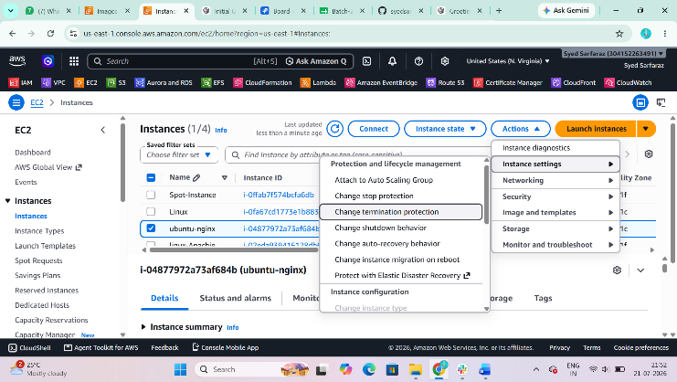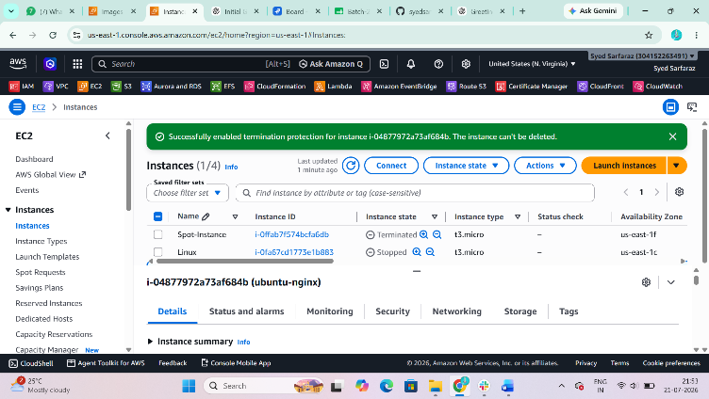
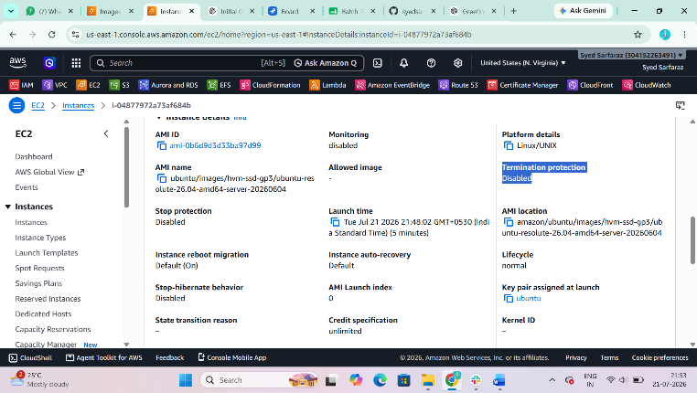
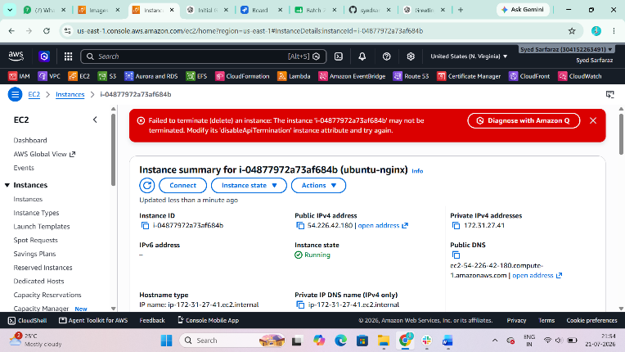

Task 8: Launch EC2 using AWS CLI
Step 1
Configure AWS CLI
aws configure
Enter
Access Key
Secret Key
Region
Output format
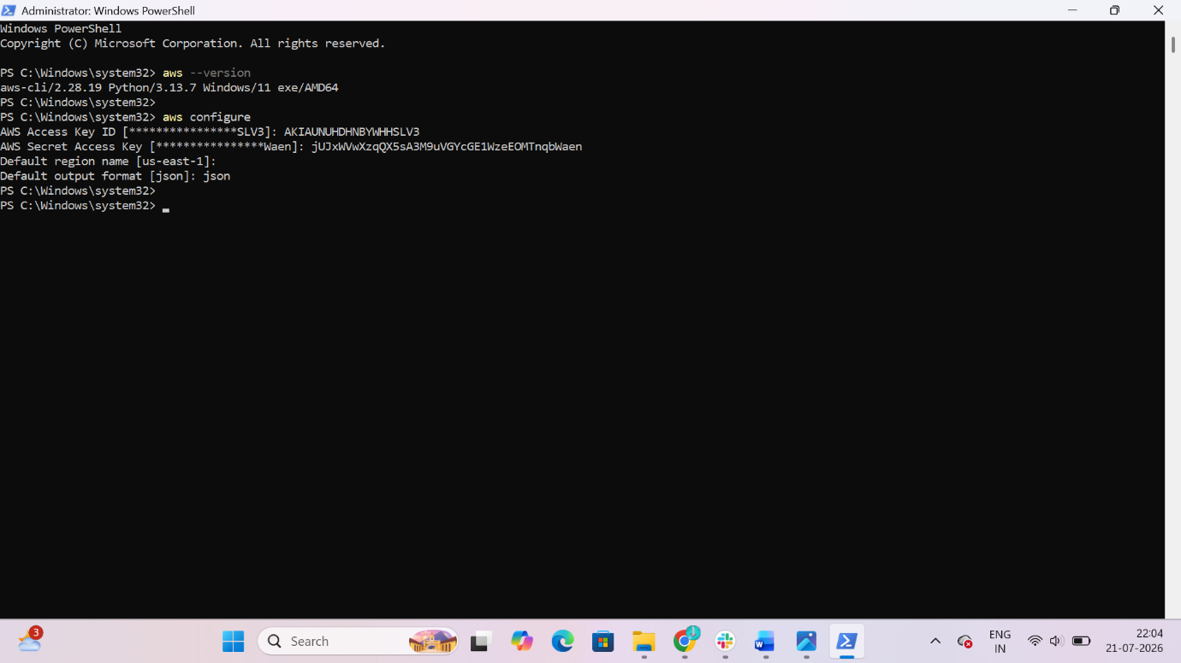

Step 2
aws ssm get-parameters --names "/aws/service/ami-amazon-linux-latest/al2023-ami-kernel-default-x86_64" --query "Parameters[0].Value" --output text

output:
ami-0f303bae6b670e0ed

Step 3
aws ec2 run-instances ^
--image-id ami-0f303bae6b670e0ed ^
--instance-type t3.micro ^
--key-name task.pem ^
--security-group-ids sg-0c0f1be1ff1a2304b ^
--subnet-id subnet-subnet-02783f0ee6dfc50bc ^
--associate-public-ip-address ^
--count 1
